Workshop: SQL Library
Beatriz Moreira
DAB NOV 2025
Jan 21, 2026

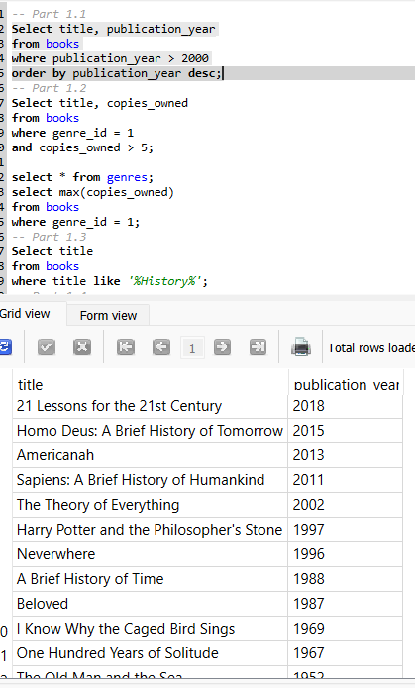

- 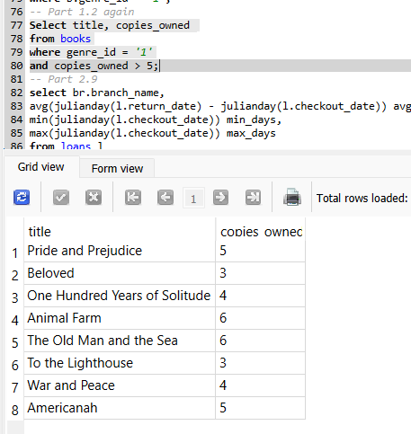
- 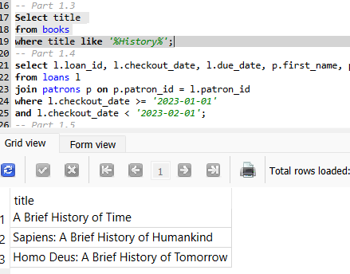
- 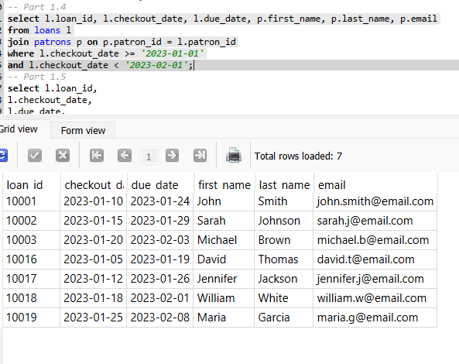
- 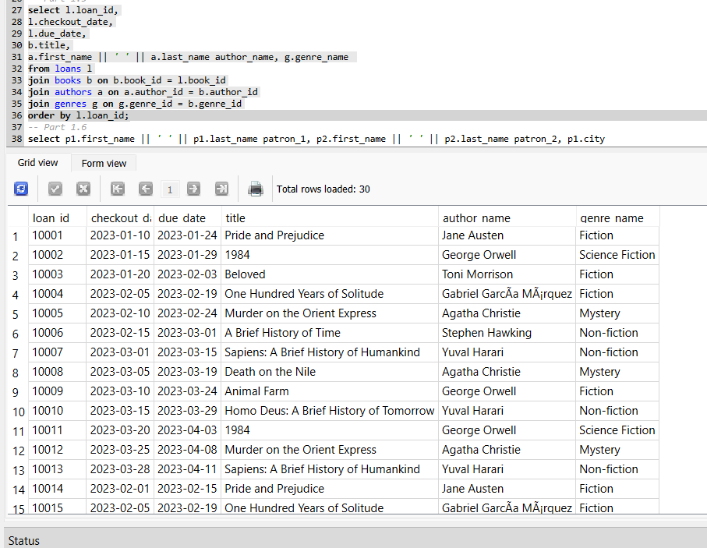
- 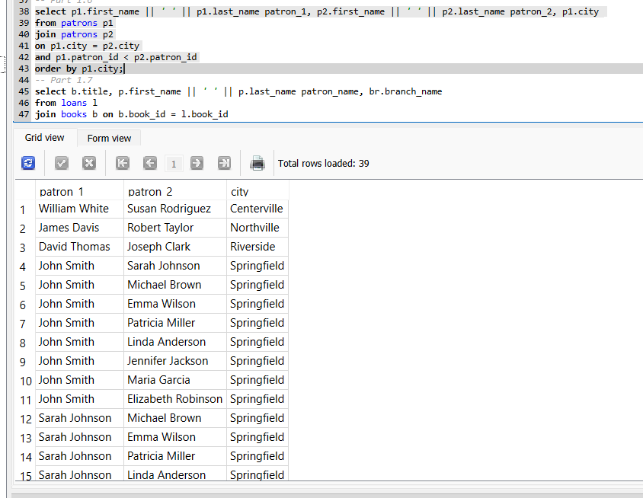
- 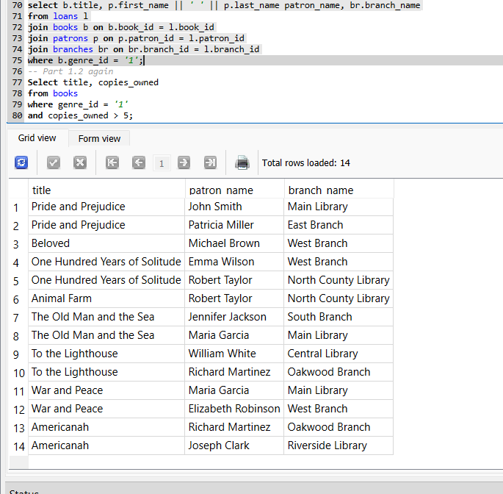
- 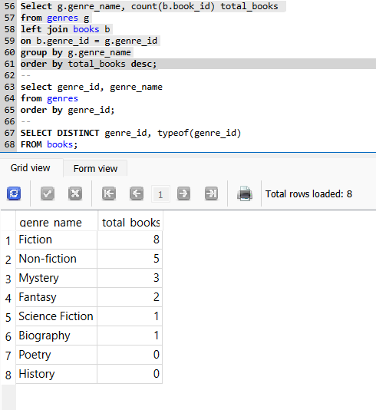
- 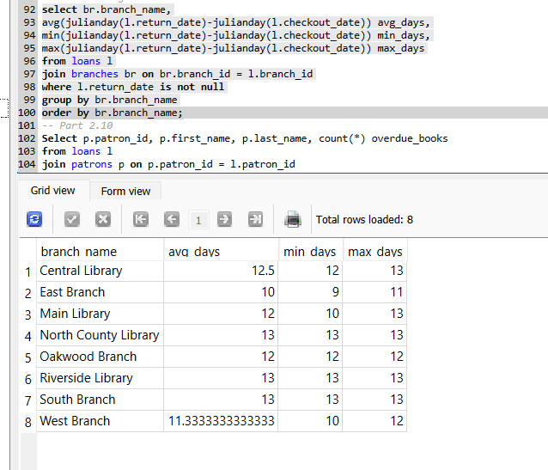
- 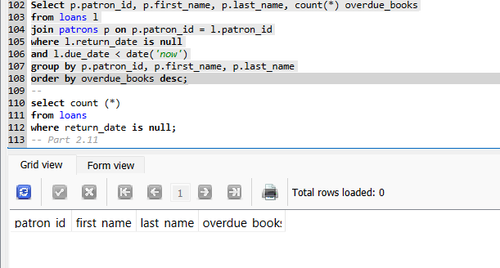
- 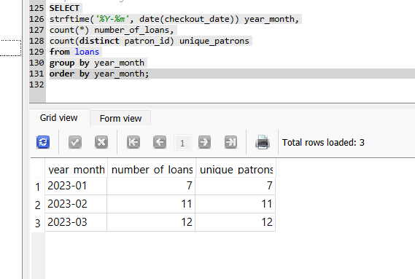
Discussion Questions
- Right now, the database tracks which branch a book was borrowed from, but it doesn’t track how many copies of a book actually exist at each branch. To fix this, I would add a separate table that connects books and branches and stores the number of copies at each location. If we keep everything in one table, we wouldn’t be able to tell how many copies are available at a specific branch. A separate inventory table would make the data cleaner and easier to analyze, especially when trying to see availability by location.
- Library administrators could answer many other business questions using this data. For example, they could see which books, authors, or genres are the most popular overall or at specific branches. They could analyze which branches have the highest borrowing activity, which patrons use the library most frequently, or which books are rarely borrowed and might not need as many copies. They could also look at borrowing trends over time to understand seasonal patterns or changes in demand.
- The schema could be extended by adding new tables for different types of patron interactions. For example, a reservations or holds table could track when a patron requests a book and whether the hold was completed or canceled. A fees table could track late fees, lost book charges, and whether those fees were paid. The library could also add tables to track participation in programs or events. Keeping these interactions in separate tables would avoid lots of empty fields and make the data easier to analyze.
- I would combine the filters from tasks 1–3 into a single query by using multiple ‘where’ conditions together. The query would filter books by publication year, use a pattern match to find titles containing the word “History,” and include a condition to only return books with multiple copies owned. This could be done by selecting from the ‘books’ table and applying all filters at once, or by joining the ‘genres’ table if the genre name is needed instead of the genre ID. Combining these conditions into one query reduces the need for multiple queries and allows the database to efficiently return only the rows that meet all criteria.
- When working with large library datasets, performance becomes important. Indexes should be added to columns that are frequently used in joins or filters, such as book IDs, patron IDs, and dates. Queries should only select the columns that are needed instead of using ‘select *’. Filtering data early in the query can also reduce the amount of data being processed. For large reports, it may be better to store summary tables rather than recalculating totals every time.

